Blood Bank Management System (BBMS) Project

UML Diagrams:
A UML Diagram is a standardized visual representation used to specify, visualize, construct, and document the artifacts of a software system.

- Structure Diagram:

- Class Diagram
- Represents the static structure of a system, showing its classes, attributes, operations, and relationships.

- Behaviour Diagram

- Use Case Diagram
- Illustrates the interactions between users (actors) and the system, outlining the system's functional requirements.

- Activity Diagram
- Depicts the flow of activities or actions within a system, showing the sequence and conditions for coordinating tasks.

- Sequence Diagram
- Details how objects interact in a particular sequence, showing the order of messages exchanged between objects to perform a function.

- Class Diagram:

Class Diagrams are the main building block of any object-oriented solution. It shows the classes in a system, attributes, and operations of each class and the relationship between each class.
Class Diagrams has 3 parts:
- Name at the Top
- Attributes in the middle
- Operations or methods at the bottom
BLOOD BANK MANAGEMENT SYSTEM CLASS DIAGRAM
– is a designed structure that shows the system classes and their relationships. This diagram is made to guide programmers along with the Online Blood Bank Management system development.

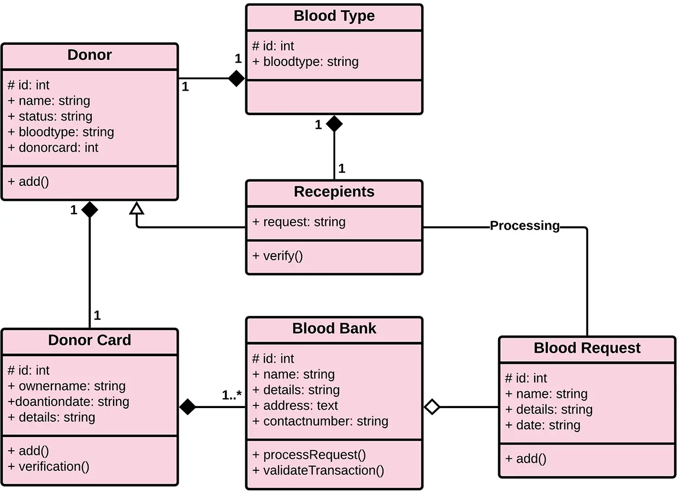

- Use Case Diagram:

Use case diagrams give a graphic overview of the actors involved in a system, different functions needed by those actors and how these different functions interact.
In this diagram,
- Use cases are represented by oval shapes, and the lines then show at which point an actor/user participates and interacts with their corresponding use case.
- Each actor is involved in the entire process.
- The admin has the access to add hospitals, organization, and blood banks. Whereas, hospitals and Users have the ability to search the donor and blood bank.
- Both Admin and User can manage their profile and can log in/log out of the system.
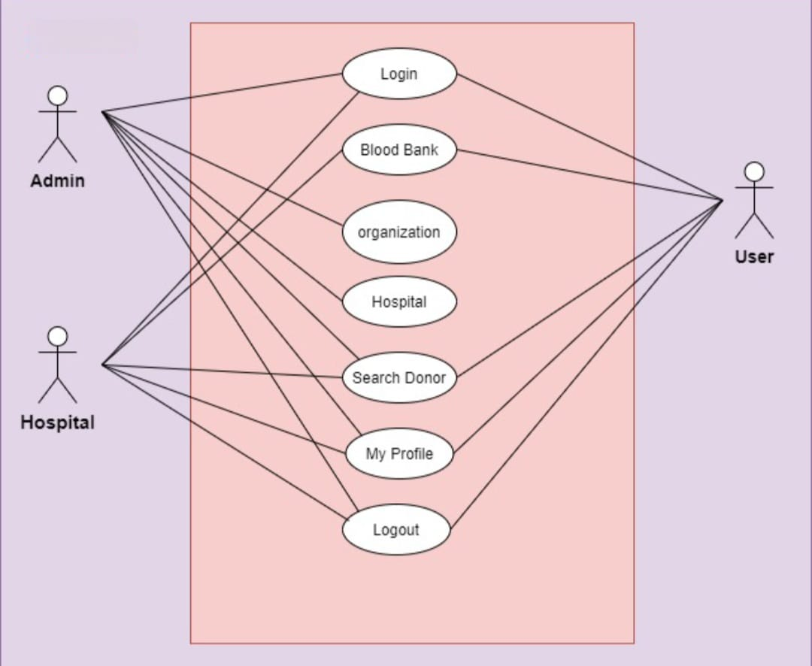
- Activity Diagram:

Activity diagrams in UML are a leading subset of behavioural diagrams. They display the functionalities of various activities and flows in management processes and software systems. The flow in the activity diagram can be sequential, branched, or concurrent.

Admin being the primary user, have to register on the system to carry out further operations of managing the system. Admin is can accept and reject users’ requests. Admin will solely be responsible for adding hospital, and blood banks.

Users after logging in can search donors, and blood banks by using search filters. A list of donors and blood banks will appear and then the user can select a particular donor and blood bank.
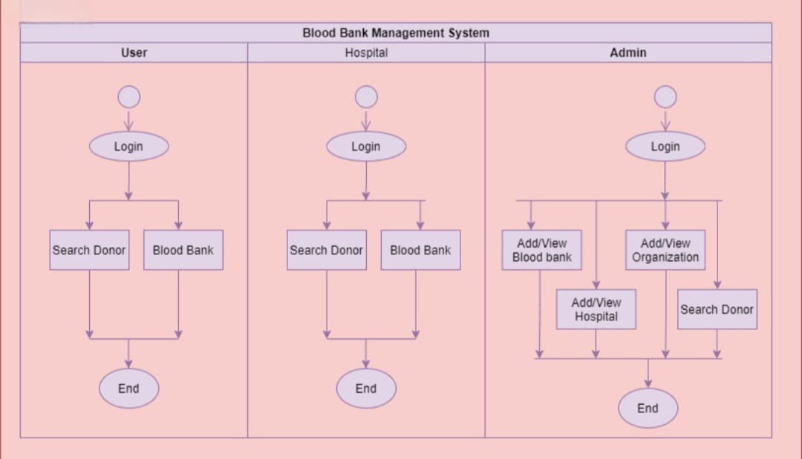

- Sequence diagrams:

Sequence diagrams in UML are used to get a better idea of how tasks within a project will function, overlap, and move between objects or components. Sequence diagrams display step-by-step interactions between objects and the order in which those interactions occur.
Users can search for specific donors or blood banks according to their preferences and select likewise. Upon selecting a particular donor, the user can contact the donor for blood donations
